Advanced Microeconomics: Theories of value and distribution

Question set #2

(**Due on October 23, 2017**)

|  |  |  |
| --- | --- | --- |
|  | Your points | Possible points |
| Q1a | 9 | 9 |
| Q1b | 25 | 23.5 |
| Q2a | 9 | 9 |
| Q2b | 17 | 17 |
| Q2c | 23 | 23 |
| Q2d | 17 | 5 |
| Total | 100 | 86.5 |

*General Instructions*: Read the questions carefully and make your answers as precise as possible. The answers should be submitted in electronic format compatible with Windows OS.

1. Answer the following questions based on the transactions table shown below. Assume that the physical quantities of commodities shown in the transactions table include only the means of production used up.

|  |  |  |  |  |
| --- | --- | --- | --- | --- |
|  | **Transactions Table** | | | **Gross output** |
| Iron | Coal | Wheat |
| Iron | 90 | 50 | 40 | 200 |
| Coal | 120 | 125 | 40 | 500 |
| Wheat | 60 | 150 | 200 | 550 |
| Units of labor | 11 | 19 | 30 |  |

1. Calculate the technical coefficients matrix ( $A)$ and the vector of labor coefficients of the system and display it in a table. Explain in words the meaning of the numbers appearing on the row “Units of labor” in your table. **9 points**
2. Derive the Leontief inverse that corresponds to the $A$ matrix that you calculated and display it in a table. Explain in words the meaning of the numbers appearing under the column “Wheat” in your table. **25 points**
3. Answer the following questions based on the technical coefficients matrix ( $A)$ and the vector of labor coefficients that you calculated in your answer to Question 1, part a.
   1. What is the maximum rate of profit? Show your calculation in terms of the maximum eigenvalue of $A$. **9 points**
   2. Calculate the embodied labor in (total labor requirements) for each commodity. Explain in words the meaning of the number that you obtained for the embodied labor in iron. **17 points**
   3. Assume that the general rate of profit is 10 percent. Calculate the associated prices and wage using the net product as the numeraire. (*Hint*: you have to first calculate the net product from the transactions table.) **23 points**
   4. Explain in words how the prices would allow the capitalists in the wheat industry to recoup their capital with profits and pay their workers. (*Hint*: Use the arithmetic that we did for an industry in the two-industry case that we discussed in class as a template). **17 points**

SEE NEXT PAGE

# Advanced Microeconomics: Theories of value and distribution #2

**A.** Given the Transactions table (above), there are two following matrixes derived: (1) tech coefficients matrix **A**; (2) labor coefficients vector **l** (see below).

**1.**

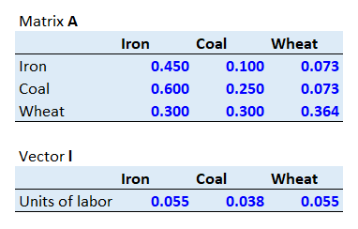

Meaning of the vector **l** coefficients: for example, it is required **0.055** as quantity of labor to produce a unit of gross output in the iron industry as well as in the wheat industry. In the coal industry, it required **0.038** quantity of labor to produce a unit of output there.

**B.** The Leontief inverse:

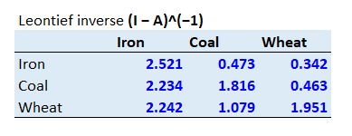

The data in the column “Wheat” represent quantities of commodities that *directly and indirectly* go (being used) into produce one unit of wheat as net product. Hence, production of wheat required much greater inputs of wheat (seeds planted and later harvested) than of iron and coal, which are naturally required *directly and indirectly* in the wheat production as inputs into machinery and fuel. Your answer is mostly correct but not an interpretation of the numbers. A more appropriate answer would be: “to produce one unit of wheat as net output we need, directly and indirectly, 0.342138 units of iron, 0.462893 units of coal, and 1.950943 units of wheat.”

**A.** Maximum rate of profit is **34.4%** as maximum eigenvalue of matrix A is derived (through calculation, which is attached in the Excel file sheet “Sraffa”, and then confirmed by STATA) at **0.744131**.

**2.**

**B.** Vector of labor embodied for each commodity:

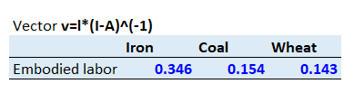

The data for labor embodied in iron, which is **0.346**, means quantity of labor that is *directly and indirectly* needed to produce one unit of the commodity as net product.

**C.** The resulting table of the calculations (attached in the Excel file sheet name “Sraffa”) with wage (w) and prices (vector **p**):

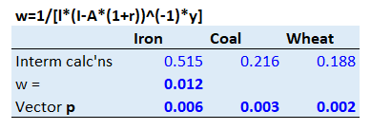

**D.** In the current system the wheat industry has rate of profit of 34.1%, which is quite close to the maximum rate of profit we derived above (34.4%). At the same time other sectors of the economy have sizably different rates of profit if compared to Sraffa system’s maximum rate – respectively, iron has 11.1% and coal has 75.4%. Hence, it is not the wheat industry that has most acute deficit/surplus, which most likely will be corrected if prices start changes due to instance wage change.

The wheat industry price equation could be written in the following ways:

*Wheat*: (60*p1+150*p2+200*p3)*(1+r)=550*p3

Or

*Wheat*: 60*p1+150*p2+200*p3 = 410*p3 + 140*p3

Where r is rate of profit and p3 is price of wheat, while p1 and p2 are prices for iron and coal respectively.

A correct answer would be: “The wheat industry will sell its 550 units of output at the unit price of 0.0022652419, thereby realizing a gross revenue of approximately 1.246. To repeat the production cycle, the industry will purchase 40 units of Iron at a cost of 0.248 (0.0061887013*40), 40 units of coal at a cost of 0.104 (0.0026004284*40), and 200 units of wheat at a cost of 0.453 (0.0022652419*200). The total capital invested is therefore the sum of the above, or ~0.8. The net revenue (or income) of the industry that is available for distribution to capitalists and workers is approximately 0.44 (=1.246-0.80). Of this, 0.08 will go toward capitalists at a 10% rate of profits (0.08=0.8*0.1) and 0.36 will go toward paying 30 workers at the wage rate of 0.012 (0.36=30*0.012).”